0000_PMU

ITS Game Design

Unit 4

Contents

Introduction 2

Design and Development 2

Testing 4

# Introduction

The task that was required of me was to demonstrate my comprehension and ability to implement various 3D game design elements into my own functioning Unity game. The final game requires implementation of the following elements; level design, movement controls, interaction with various objects, graphical user interface (GUI), and scoring.

My 3D game will meet these requirements by designing, then developing a game that thoroughly demonstrates my knowledge of each game element. I have chosen to develop a third person survival game because each of the required components can be easily implemented. The game will require users to eliminate all of the enemies as fast as possible without dying.

# Design and Development

*Each of the required game components will be implemented by:*

***Level design:*** Developing an in-depth, interactive environment that will;

* Be built using various Unity assets
* Allow the main character the interact with the environment

***Movement controls:*** Implementing a main character that can;

* Move forward, backwards, left and right using the W,S, A and D keys respectively
* Being able to shoot using the mouse button

***Interaction with various objects:*** Interactions with other objects will be thoroughly implemented by;

* Enabling the main character to shoot from a gun
* Using collisions to detect when the enemies should die
* Adding physics to each object
* Allowing enemies to kill the main character using collision detection

***Graphical user interface:*** Implementing a main interface that will;

* Allow users to navigate to various game scenes
* A counter that will display how many enemies the main character has killed
* Displaying how long the game has been going for

***Scoring:*** Scoring will be implemented into the game by;

* Counting how many enemies the main character has killed
* Displaying how long the player has been in the game

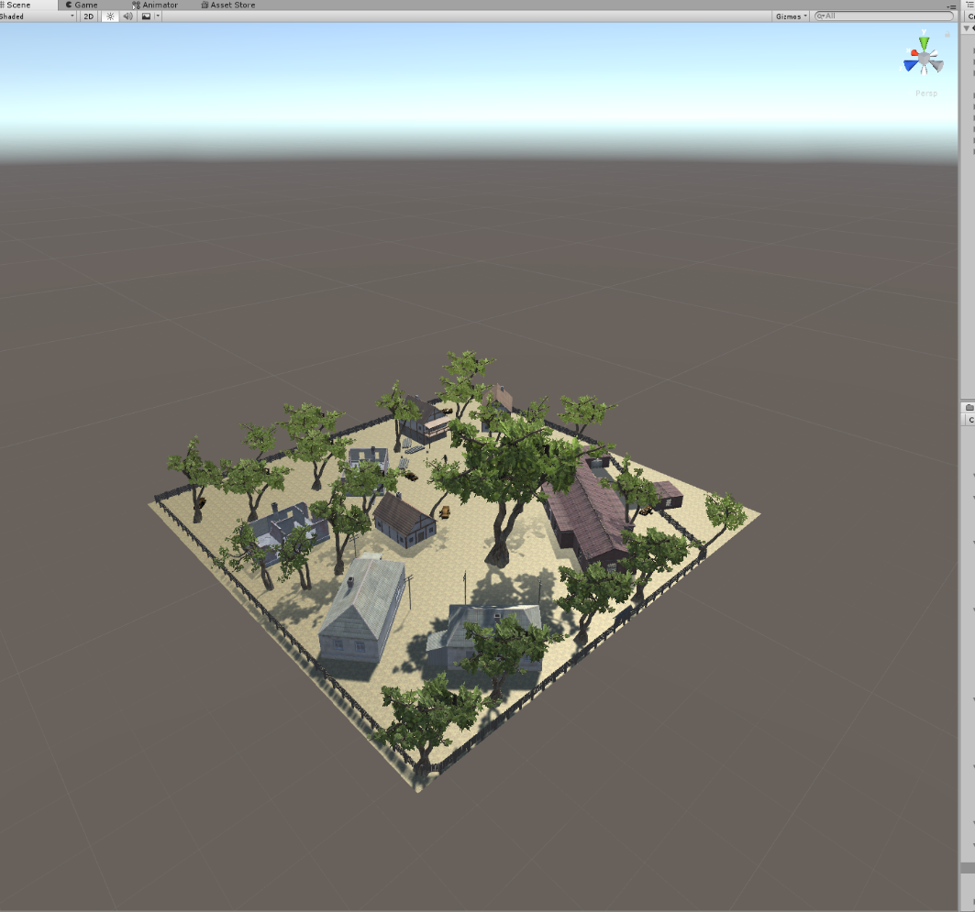

***Level design:***

I first started the development of the game by designing an interactive environment. The environment was developed using various unity assets, then using unity’s physics system to incorporate basic physics for all of the elements. The environment was designed to look like an apocalyptic town, this helped to keep with my game theme of survival shooter.

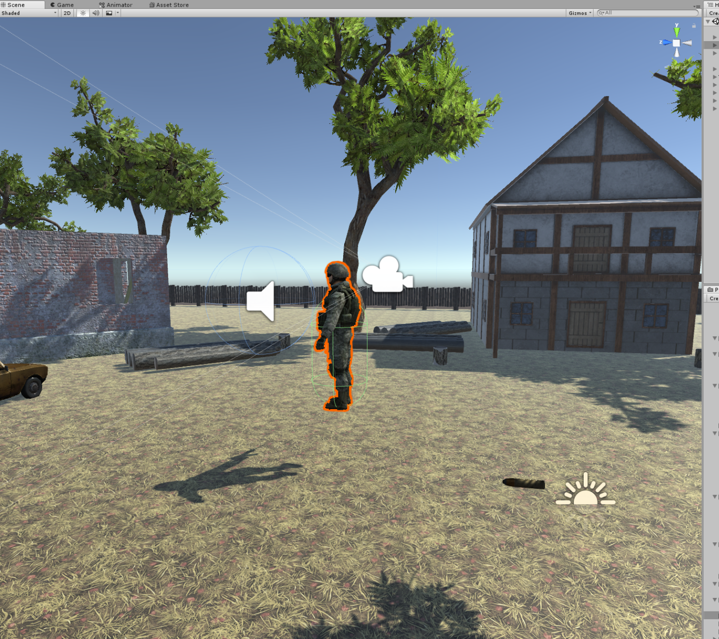***Player development:***

I next added a main character that can be controlled by the user, this was achieved using various scripts and player controllers. The character was developed using a unity assest and adding basic physic systems to make realistic movements. I attached a camera to the character so the character can be in constant view of the camera throughout the game. Finally, I added a script that allows the cahracter to shoot by projecting a bullet every time the left mouse button is pressed, this will be used to kill the enemies .

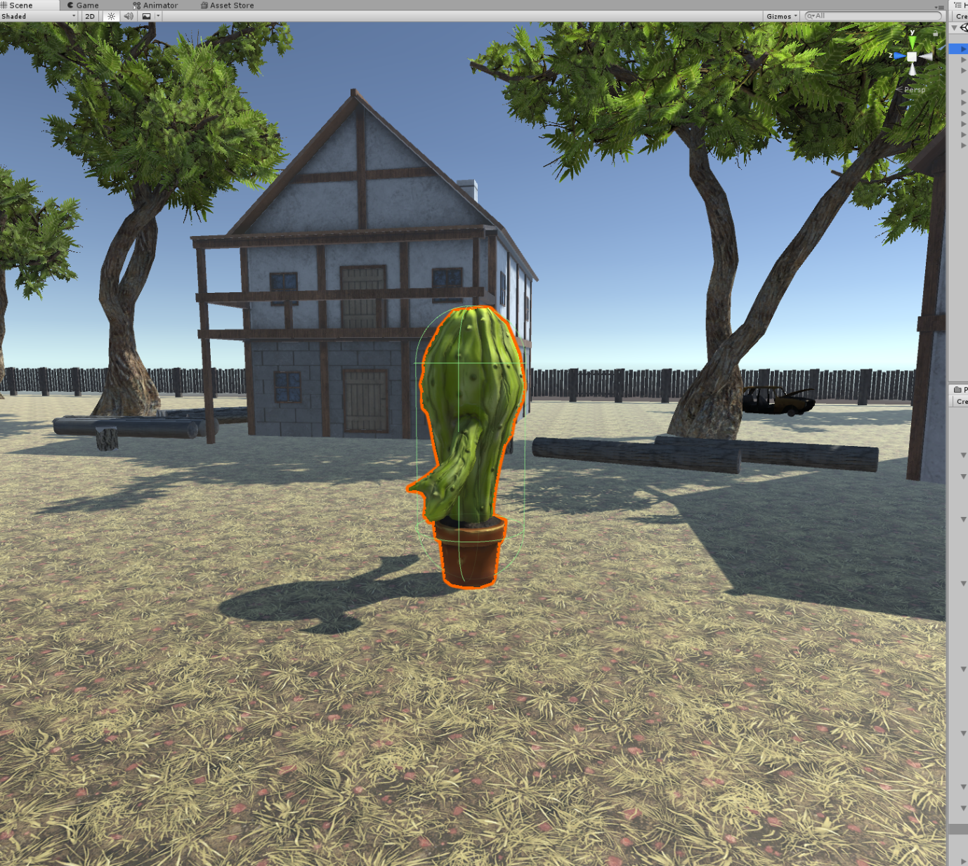***Enemy development:***

I next developed enemies for the character to kill. The enemies were developed using a Unity asset, then adding various scripts to allow them to follow the character and damage the player’s health when they’re close enough. I also added basic physic systems so the enemies cannot walk through solid objects. The enemies will be following a path that is set to them at the start of the game, then once the player is in a certain proximity of the enemies, the specific enemy will start chasing the character.

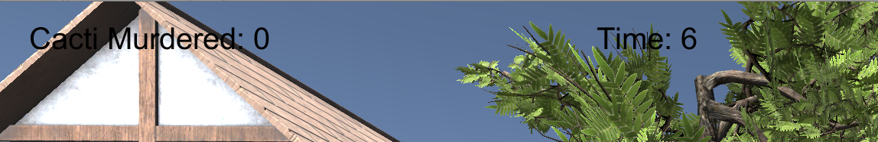***Counter and timer development:***

I next developed the counter and the timer for the game. These were developed let players know how long their game has been going for if they are trying to beat the highest score. The counter was developed to let players know how many enemies they’ve killed. The timer and counter are displayed on the screen using UI text.

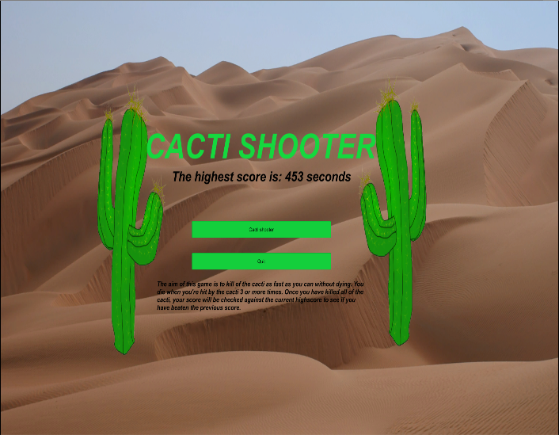***Main Menu development:***

After finishing the main game, I developed a main menu. The main menu was developed using basic UI elements, such as, buttons, text, and images. The main menu will greet players when they first launch the game and when the game finishes. On the screen there is instructions stating the purpose and how to play the game. There is also a section where it tells the users the current high score for the game, this high score will help keep the game competitive and engaging for players.

# Testing

After developing the game, I underwent a testing phase to ensure each component was effectively incorporated without any bugs that would compromise the playability of the game and if the game demonstrate the require components sufficiently. I tested the game by getting several of my fellow peers to play the game, then asking them to give feedback regarding how effective every component has been incorporated.

The feedback I received during the testing phase was:

* The game sufficiently meets all of the required components
* Has been effectively designed as a fully functioning game
* Appropriate assets have been used
* The game is enjoyable because it has implemented simple elements that have been effectively designed and developed
* The game is fun, enjoyable and easy for users to play

From the feedback I received, I spent extra time developing the game level even further to incorporate more user interactions with other objects. These additions include; making the game more user centred by making the enemies attack the player whenever they’re in close proximity instead of automatically attacking the player. I also added a leader board to the game that shows how quick other users have finished the game. This will help to make the game more interactive because users will keep trying to beat their time and other user’s times.

# Evaluation

This project was used to demonstrate my comprehension and ability to implement various Unity elements into a fully functioning game. The final game required various game components, these include; in-depth level design, player movements, interactions with various objects, graphical user interface, and scoring systems. These game components were effectively demonstrated by creating a basic third person survival shooter that thoroughly incorporated these elements.

A reasonable timeframe was given to develop and document the project, meaning a well-developed game was produced. However, if other commitments such as other subjects and work didn’t interfere with the timeframe, more time could’ve been allocated to developing a higher quality game.

Throughout the development of the game various resources were used to help advance components of the game further. These resources include; video tutorials to assist with developing complicated elements, and teacher and peer support to help evaluate the successfulness of specific game components. The Unity Store was also used heavily throughout the development for downloading and integrating various assets to make the game look professional and more engaging. Having a reliable access to Unity at home meant significantly more time was spent developing the game.

Planning of the game prior to developing was useful in making the development process easier because the planning effectively outlines the requirements of the task and how those requirements will be thoroughly integrated. Setting a timeframe for when specific game components should be finished meant the game was meticulously developed, instead of spending more time on one component then rushing through the rest of the components to create a partially functioning game.

The final game implemented all the task requirements effectively. This is because all the game elements were kept simple, not adding in any complicated components that would make the development too difficult and time consuming. This allowed more time to be allocated to making sure every component worked perfectly without any bugs that would compromise the integrity of the game. From the feedback received by fellow peers, most agree that the final game has effectively met all the task requirements to a sufficient level.

The final game was very engaging for all the players who played it. The game is engaging because it was effectively designed to be challenging for players by implementing a high score that pressured players to keep playing the game until they had beaten the current high score. The game is also very simple to play, has visually appealing textures, and is an interesting game to play because players must kill cacti as fast as they can, which unique. However, some possible improvements that could be made to the game to make it more engaging for players are; making the top 10 scores appear on the highest score instead of one to make the game more competitive, making the Cacti shoot spikes to kill the main player, and adding more animations to the main player and the enemies to make the game more in-depth. Also, more game styles could be added to develop the game father and make it more engaging for the players. Finally, further research on third person survival games could be conducted to improve the camera angles and GUI of the game.